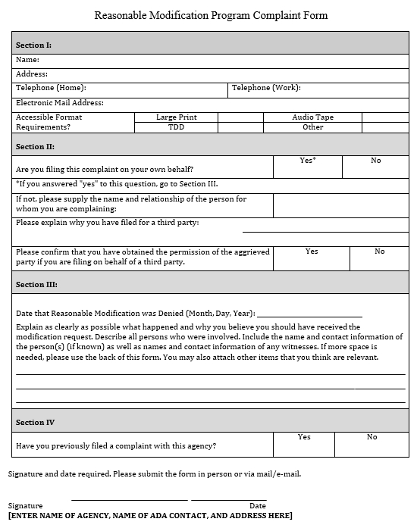

DeKalb Area Rural Transit (D.A.R.T.) Tracy Bell – Executive Director

1800 E. 7th Street, Auburn, IN 46706. (260) 925-3311

tbell@dccoa.net

____________________________________________ ________________________